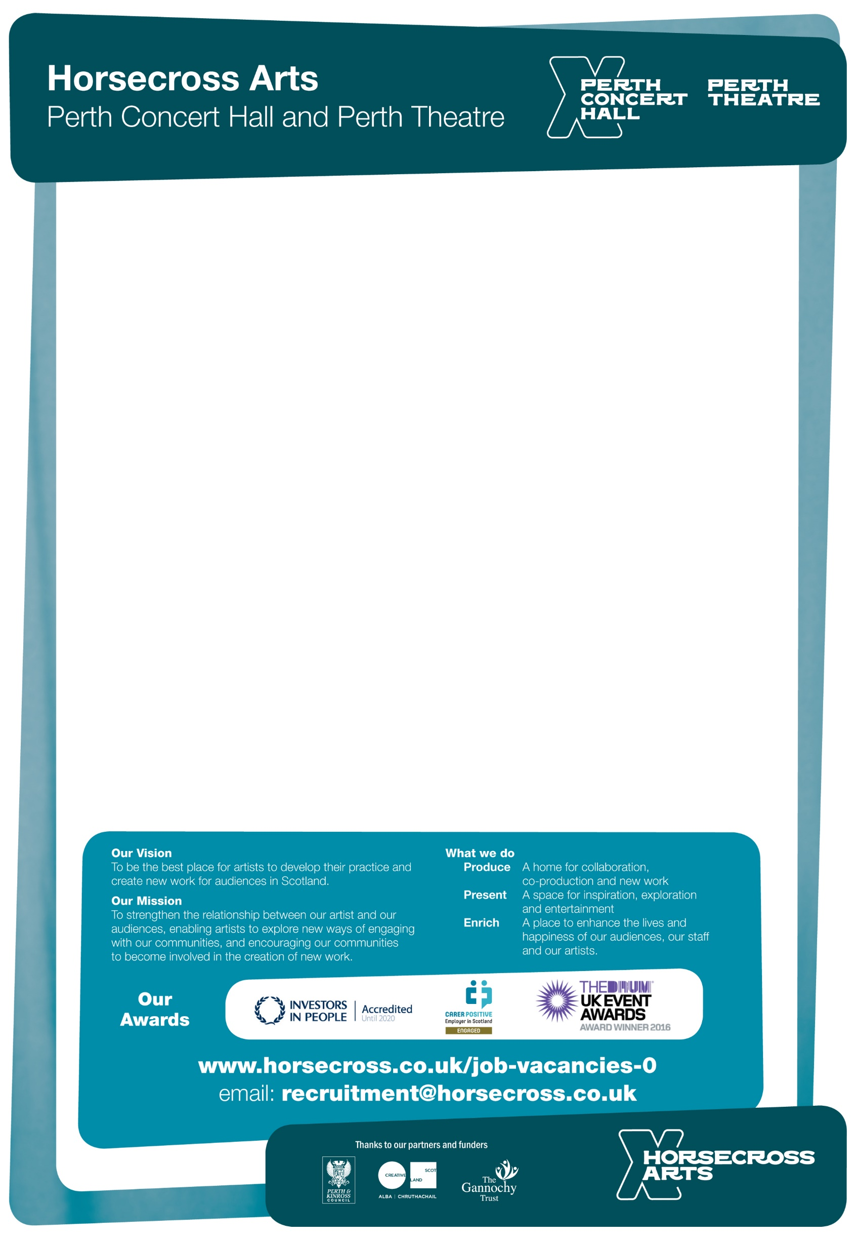

Scottish registered charity no SC022400

**We are hiring - Bar Staff**

Feeling bored, fed-up and frustrated? Then why don’t you come to work with us in the best two venues in the town where two days are not the same!

Our bar staff are required to deliver the highest standards of customer service within the catering operations, bars, conferences and events.

We’re here to create a buzz; to inspire, entertain and delight. When you join Horsecross you’re not just turning up for work; you’re buying into an organisation that wants to be the best. We can guarantee that once you join our catering family you’ll have fun, create strong friendships and together we shall provide excellent customer service in our bars and restaurants and ensure both venues continue to be award-winning for all our customers.

**Bar Staff - No Guaranteed Hours**

**Hourly rate: £7.83 (min shift: 3 hours)**

Flexible hours including evening and weekend work

Age 18 or above

**Staff benefits**

* Free and discounted tickets for select Horsecross concerts and events
* Reduced rate on local authority gym and leisure memberships
* Discount on select meals from the Perth Concert Hall’s café and restaurant
* Be part of an award-winning team!

**NO CV's PLEASE**

Application packs & further information on these roles are available from our website: <https://www.horsecross.co.uk/job-vacancies-0>

or email [recruitment@horsecross.co.uk](mailto:recruitment@horsecross.co.uk)

Horsecross Arts Ltd, Perth Concert Hall, Mill Street, Perth PH1 5HZ