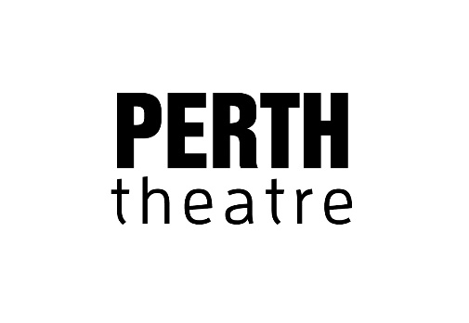

ANIMALS
Created by Greg Sinclair, a co-production with Perth Theatre

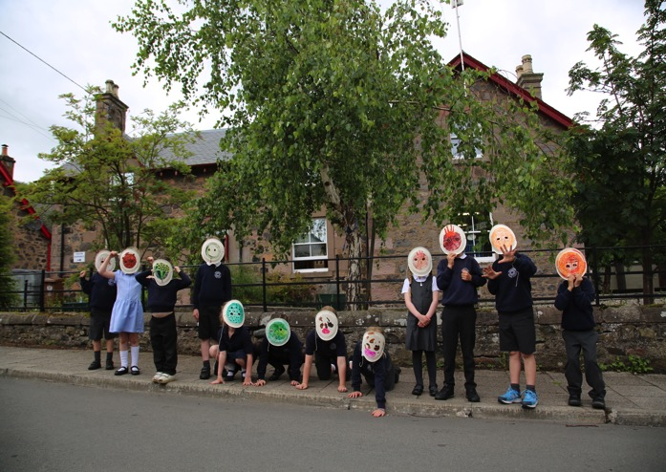

Image credit: Geraldine Heaney - Children from Forgandenny Primary during the Animals R&D

ANIMALS is a show about… animals. Big ones, little ones, wild ones, tame ones. It’s also a show about us, and our emotions. Big ones, little ones, wild ones, tame ones.

From the joy of delivering a new lamb with your own hands, to the pain of losing your pet dog, and the confusion of discovering your favourite cow is in love with a tractor! - ANIMALS explores how animals help us figure stuff out.

Using real and imagined stories told by 6 year-olds, join us as we interweave live music, dance and film into a celebration of our unique relationship with animals.

A show for 6years+

Links to the curriculum

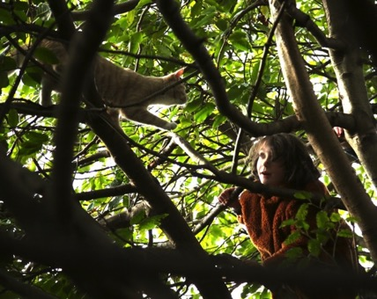
Image credit: Geraldine Heaney – Ada and Cat

ANIMALS can assist teachers to deliver Curriculum for Excellence Experiences and Outcomes in the following areas:

Expressive arts
My learning in, through and about the expressive arts:
- Enables me to experience the inspiration and power of the arts
- Is enhanced and enriched through partnerships with professional arts companies, creative adults and cultural organisations

EXA 0-15a/1-15a/2-15a: I can respond to the experience of drama by discussing my thoughts and feelings. I can give and accept constructive comment on my own and other’s work.
EXA 1-19a/2-19a: I have listened to a range of music and can respond by discussing my thoughts and feelings

Literacy and English
I develop and extend my literacy skills when I have opportunities to:
- Explore the richness and diversity of language, how it can affect me, and the wider range of ways in which I and others can be creative
- Extend and enrich my vocabulary through listening, talking, watching and reading

LIT 1-01a/2-01a: I regularly listen to or watch texts which I enjoy and find interesting and can explain why I prefer certain sources.
LIT 1-04a: As I listen or watch I can identify and discuss the purpose, key words and main ideas of the text and use this information for a specific purpose
ENG 1-03a: I am exploring how pace, gesture, expression, emphasis and choice of words are used to engage others.

A more comprehensive workshop pack will be available for schools to use post-performance. The workshop pack will include further links to the Curriculum for Excellence that can be used in the classroom to enhance the learning and experience of the children who have attended a performance.
ACCESSIBILITY

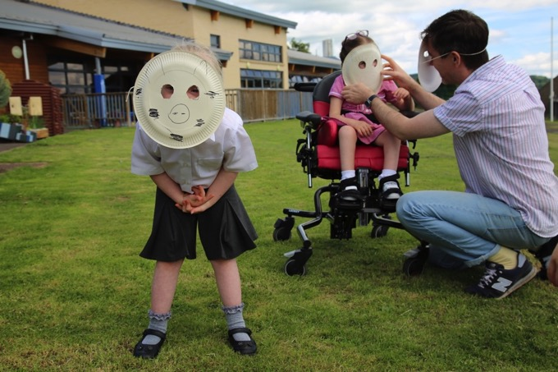
Image credit: Geraldine Heaney - Children from Fairview during the Animals R&D

ANIMALS was created with the participation of Fairview School SEN in Perth. Workshops at Fairview involved the team learning about the communication and access needs for those particular children, but in so doing, learning about how to make the show accessible to a wide range of people. Some workshop tasks we did:

- Creating animal masks from paper plates
- Restaging photos of animals
- Going for walks outside
- Using photos of animals to help with understanding when talking about them
- An animal sounds quiz
- Learning the signs for various animals
- Using electronic picture devices to enable non-verbal children to communicate and participate in tasks
- Recording stories about pets, going horse-riding and the visiting Therapet dogs

How accessibility will be utilised in the show:

We are using a number of theatrical and communication devices to make the show as accessible as possible. These include the following:

- Sending out information packs in advance with photos of cast, set, theatre staff/ venue (where possible) and other helpful information such as route to theatre, things to expect in the show, some examples of musical sounds such as cello
- ANIMALS has a highly visual and physical theatrical style. Greg’s work is an exploration of how to make sound and music into a visual/physical experience. This makes it more accessible for deaf/hearing impaired individuals and can also benefit learning disabled audience members.
- Use of film to provide key captioned words, pictures of animals that are being discussed, images of children with animals to indicate relationships
- Use of audio of children’s voices. The performers will also employ theatrical devices such as lip-synching, signing, gesture, repetition of key words to ensure the main points of the stories as accessible as possible.
- There may be the option for post-show workshops where the audience will be able to meet the cast and ask some questions, touch the set – please contact the venue to discuss setting this up.

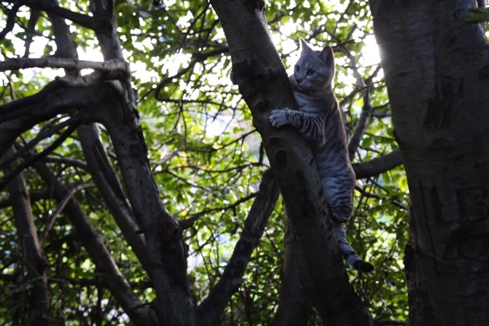Image credit: Geraldine Heaney – Cat

Meet the Creative Team

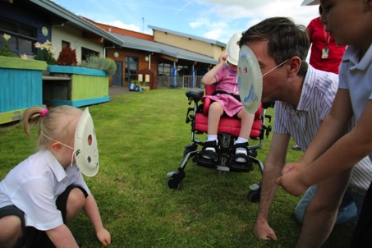
Image credit: Geraldine Heaney - Children from Fairview during the Animals R&D

Greg Sinclair – creator, performer
Hannah Venet – co-devisor, performer
Geraldine Heaney – video artist
Katy Wilson – designer
Lu Kemp – dramaturg

Greg Sinclair is an award-winning musician and performance artist. He is the 2016 recipient of a Children’s Theatre fellowship from The Arts Foundation and has won a CATS award for best children’s theatre show for Sonata for a Man and a Boy.

Greg will devise and perform the work with dancer/choreographer Hannah Venet. Greg and Hannah have previously worked together on Mamababame, a dance production for early years by Curious Seed and Starcatchers. They share a similar ethos of working collaboratively with children to make performance work; Hannah is a former Imaginate artist in residence and during this residency made Trio which was performed by herself alongside a girl and a boy.

The designer Katy Wilson has a vast amount of experience working within the children’s theatre sector, both producing her own work such as Blue Block Studio and Sprog Rock, and as a set designer on productions such as the award-winning Too Many Penguins? by Frozen Charlotte. Katy has a bright and colourful visual aesthetic which will be important within Animals.

The film artist Geraldine Heaney has worked in numerous roles in the performing arts but it is her skill as a film-maker that will be used in Animals. As the films will feature child performers Geraldine has been chosen because she has such experience of working with young people. Her film aesthetic is playful and fun and works well alongside music. Geraldine will also create video material that will increase the accessibility of the work to audience members with additional needs.

Lu Kemp has worked as a dramaturg in new-writing, devised theatre and dance. She frequently works on the development of new scripts for the National Theatre Studio London and the Playwright’s Studio Scotland. She has a particular interest in creating work for young people, and in multi-form work. She is the Artistic Director of Perth Theatre.

The inspiration for ANIMALS
A few years ago I read a true story in the paper. A tractor was doing some work in a field and every day one of the cows in the field would wander down and hang out with the tractor. When the work was completed and the tractor stopped coming to the field every day the farmer noticed that the cow was behaving oddly. She was remaining separate from the herd. A vet, after hearing the story about the tractor, told the farmer that the cow was depressed; she was missing her friend.

I was really struck by the humour and sadness in this story and thought it would work well as a story to tell children. I made a scratch performance of it and this has lead to me creating a whole show about animals for children. I wanted to find stories of how animals provide lots of benefits for children: care opportunities, cuddles, socialising, friendship, dealing with illness and death, babies. The bonds that form between children and animals can be really special and unique and the animals can really help the children figure stuff out.

To make the show ANIMALS I have been working with 6 year olds in Perth at three local schools: Fairview, St Ninian’s and Forgandenny. The children have shared stories with me about their relationships with animals, and I have recorded their voices telling the tales. There are stories of naughty sock-eating dogs, runaway cats, “male” guinea pigs having babies, helping with the lambing, and Shetland ponies going on holiday to Shetland. I was really fascinated by the range of stories and how eager the children were to share them with me.

Some of these collected stories will be performed by myself and co-performer in ANIMALS, Hannah Venet. We’ll use the children’s recorded voices, live music, movement and film to bring the stories to life. The children that helped us to make the show will also feature in it in a series of short films. These films will be little surprising vignettes showing the children interacting with various animals.

We really hope you enjoy ANIMALS and look forward to seeing you at a performance.

Greg

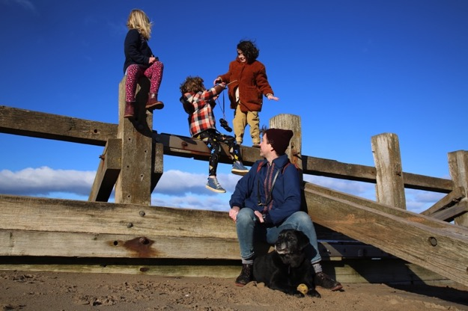
Image credit: Geraldine Heaney – Beach Adventures

